|  |  |
| --- | --- |
| **Assignment** | |
| **Course Code** | CSC402A |
| **Course Name** | Web Architecture and Application Development |
| **Programme** | B.Tech |
| **Department** | CSE |
| **Faculty** | FET |

|  |  |
| --- | --- |
| **Name of the Student** | Satyajit Ghana |
| **Reg. No.** | 17ETCS002159 |
| **Semester/Year** | 07/2020 |
| **Course Leader(s)** | Mrs. Sahana P Shankar |



|  |  |  |  |  |  |  |  |  |
| --- | --- | --- | --- | --- | --- | --- | --- | --- |
| Declaration Sheet | | | | | | | | |
| Student Name | Satyajit Ghana | | | | | | | |
| Reg. No | 17ETCS002159 | | | | | | | |
| Programme | B.Tech | | | | | Semester/Year | 07/2020 | |
| Course Code | CSC402A | | | | | | | |
| Course Title | Web Architecture and Application Development | | | | | | | |
| Course Date |  | | to |  | | | | |
| Course Leader | Mrs. Sahana P Shankar | | | | | | | |
| **Declaration**  The assignment submitted herewith is a result of my own investigations and that I have conformed to the guidelines against plagiarism as laid out in the Student Handbook. All sections of the text and results, which have been obtained from other sources, are fully referenced. I understand that cheating and plagiarism constitute a breach of University regulations and will be dealt with accordingly. | | | | | | | | |
| Signature of the Student | |  | | | | | Date |  |
| Submission date stamp  (by Examination & Assessment Section) | |  | | | | | | |
| Signature of the Course Leader and date | | | | | Signature of the Reviewer and date | | | |
|  | | | | |  | | | |

# Contents

Declaration Sheet ii

Contents iii

1 Question 1 4

1.1 Functional and Non-Functional Requirements 4

1.2 Identification and design of the entity classes using E-R diagrams 5

1.3 Design of UML Diagrams 7

1.4 Design of Algorithm/Flowchart 11

1.4.1 Feature Set 11

1.4.2 Flow Chart 12

Bibliography 13

# Question 1

Solution to Question No. 1

## Functional and Non-Functional Requirements

Functional Requirements

1. The system must allow authentication for users, with sign in and sign out options, with anonymous login as well
2. The system must allow the users to change their personal details on user details page
3. The system must display the list of the products
4. The system must display the highlighted products on the home screen, linked with the corresponding product detail page
5. The system must allow the user to add products to a dedicated card of the user
6. The system should allow the user to change product quantity in the cart and calculate the total amount on the fly
7. The system must have an option to check out the cart and create an order given address, shipping method and payment data with validation
8. The system should present the user with various payment and shipping methods available
9. The system must have a coupon option to be provided at checkout for discounts
10. The system must allow the user to track a created order
11. The system must allow the user to cancel or return an existing valid order
12. The system must allow the user to give rating to a product
13. The system must allow CRUD (Create, Read, Update, Delete) operations on the products for the admin
14. The system must allow merchant to add features products in the home page of the app

Non-Functional Requirements

1. The interface of the system should be clean, simple and easy to use
2. The system must be secure and compliant with PCI-DSS for payment processing
3. The system should have an intuitive UI/UX
4. The system must have proper SEO optimization
5. The system must be fast and responsive

## Identification and design of the entity classes using E-R diagrams

The identified entities were

1. User

This is the entity which signs in and signs out of the app, we use this to identify the kind of user (admin/normal user) from the roles attribute, some basic details like firstName, lastName, password, and email are attributes of this entity.

1. Product

This entity encapsulates the property of an actual product that is kept for sale (sports accessories in our case). Details like name, description, price, rating, are some of its attributes.

1. Rating

This is a helper weak entity that represents the rating of a product kept for sale, this helps the user sort the products based on their rating and choose wisely the product the user wants to buy.

1. Order

The order entity keeps track of the items added in the cart, its total price, the customer details, paymentMethod and a unique order number.

1. CartItem

This is another weak entity which just stores the product and the amount, the CartItem is a part of the order, and is used to calculate the total price of the cart.

1. Customer

Since we are also supporting authentication-less purchases, this Customer attributes is attached to every Order, which is basically the customer shipping details like address, phone, name, email. So, if we have a user, then some of the attribute details are directly taken from there, else details are prompted to be filled.

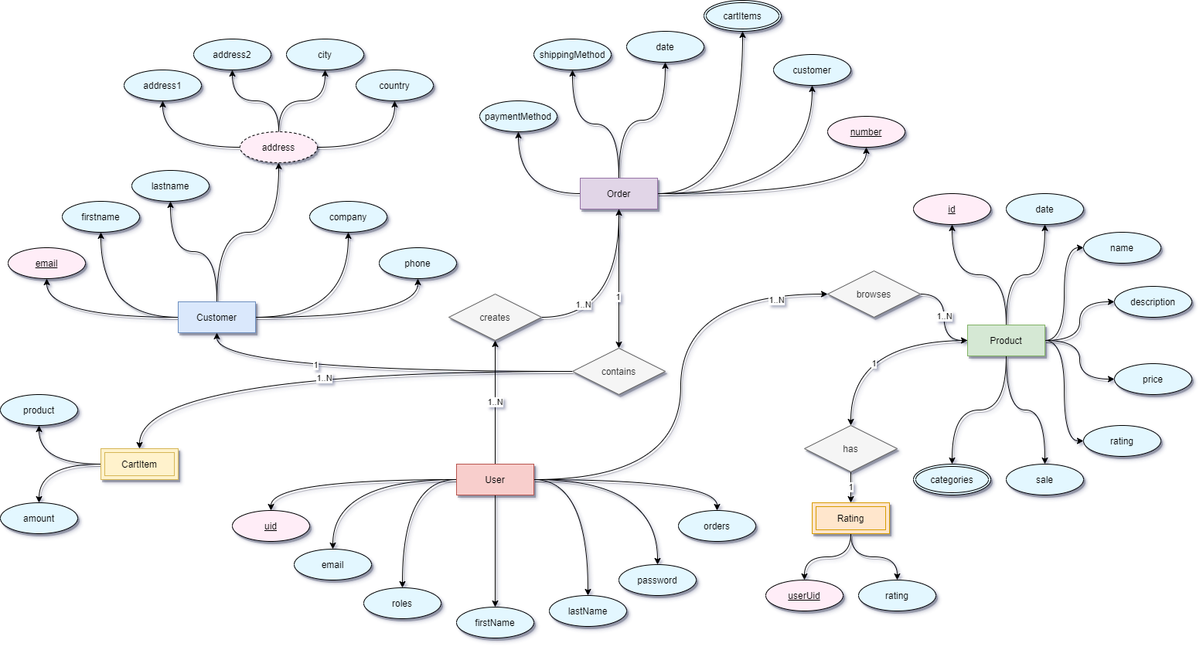

## Design of UML Diagrams

1. State Chart Diagram

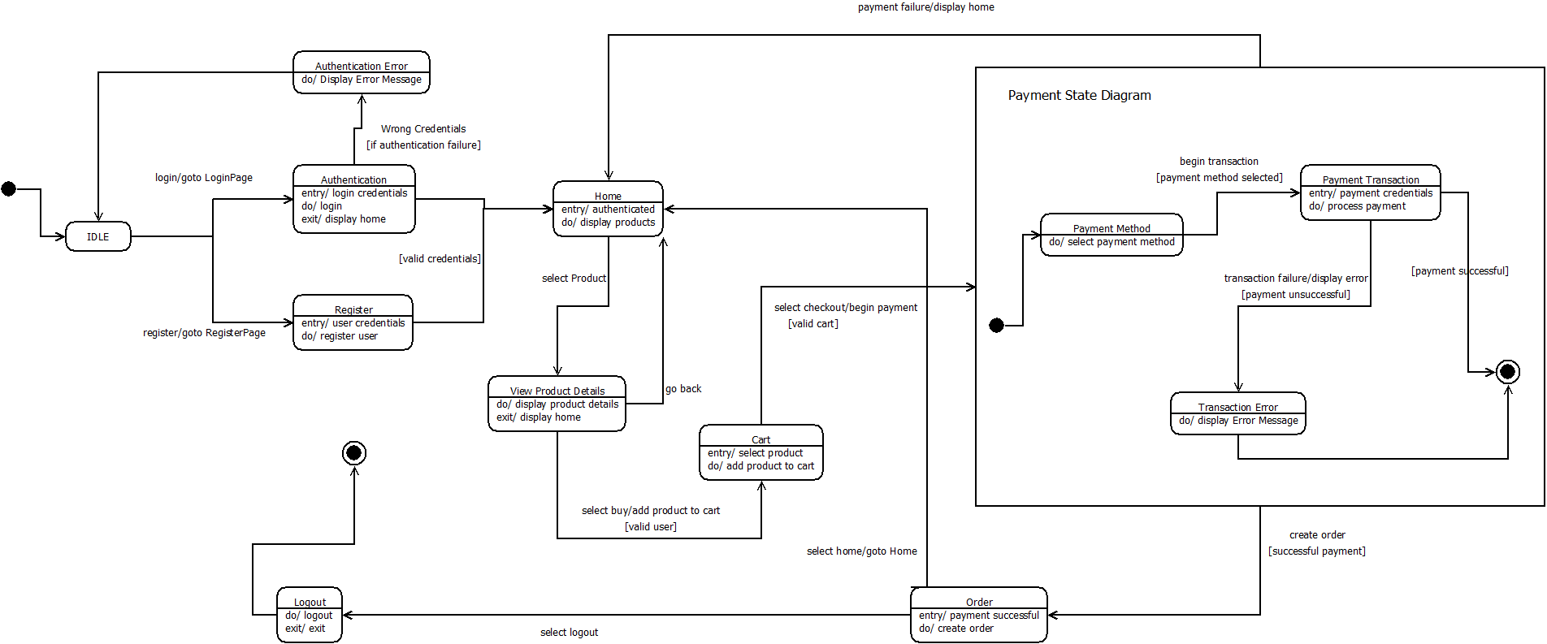

1. 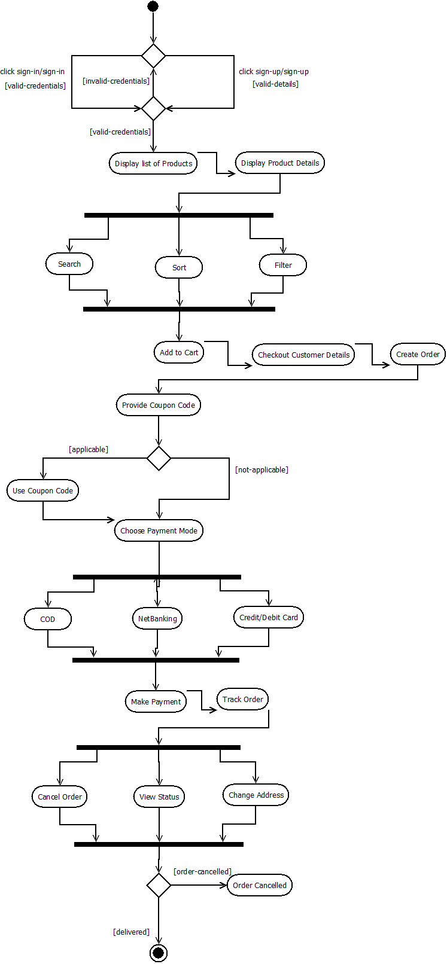Activity Diagram
2. Sequence Diagram

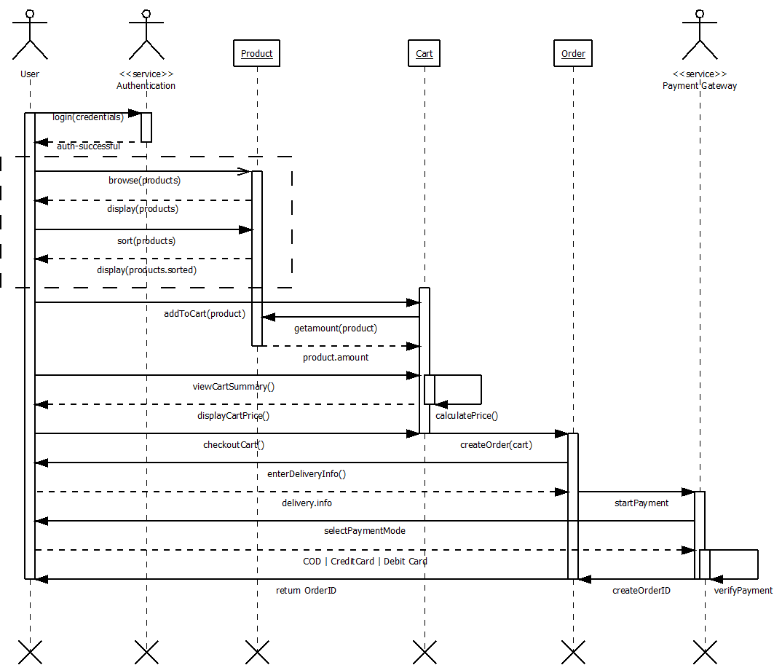

1. 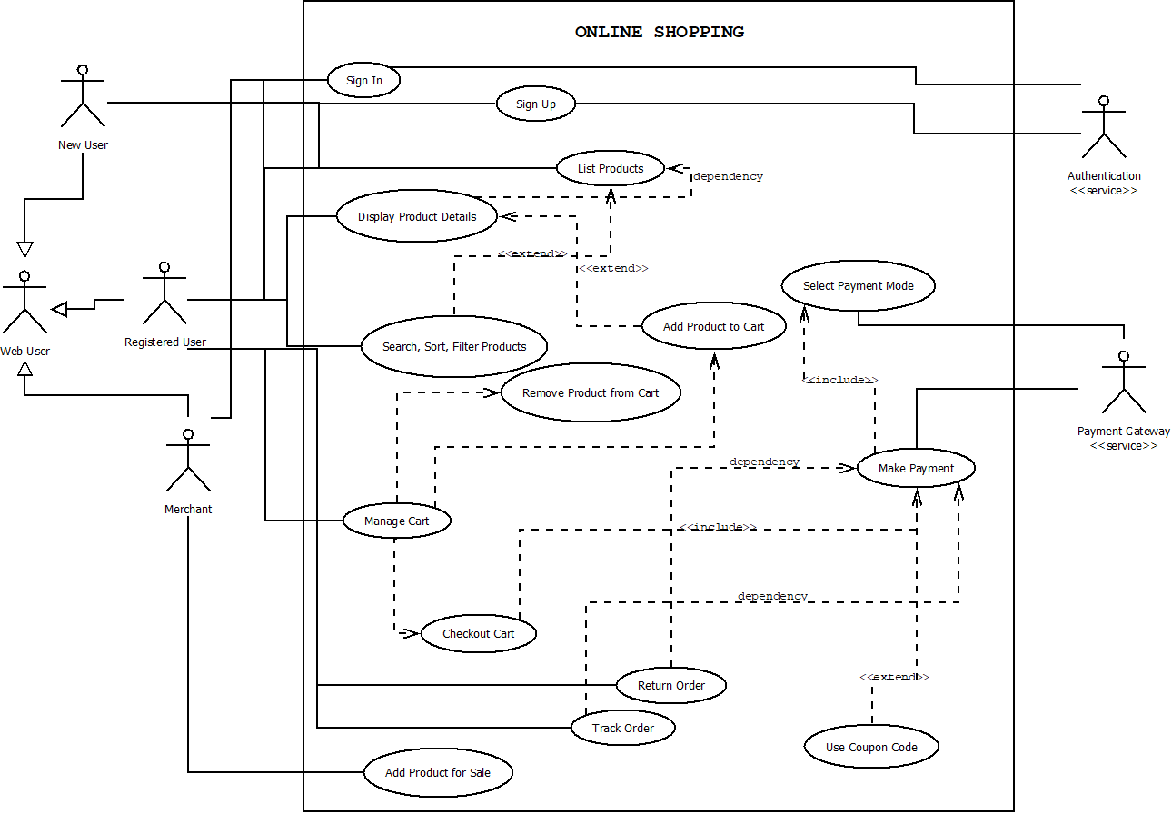Use Case Diagram

## Design of Algorithm/Flowchart

The Flowchart is well described by the Sequence Diagram, Activity Diagram and State Chart Diagram provided in 1.3. Although below is a high-level Flow chart of the Customer Interaction and flow with the Web App, along with the Feature Set the application provides.

### Feature Set

Products

* Products can be sorted based on their price, name and date created
* Products can be viewed by the user in a grid/list view
* Products are shown in pages, via Pagination

Cart

* Products can be added to the cart
* Cart is handled by a CartService
* Cart can be cleared at once
* Subtotal and Total is calculated on the fly
* Quantity of each of the item in cart can be adjusted
* Adding the same product multiple times just increments the exiting cart item’s quantity
* Cart has a dedicated page and also a mini cart at the top-right of the website

Checkout

* If the user is already authenticated then the Customer details is prefilled
* Address, Shipping method and Payment Data validation
* Anonymous user can also create orders
* Order summary is created once order is done

Authentication

* Role based authentication (user/merchant/admin)
* Login using existing account
* Order history
* User details are updatable

### Flow Chart

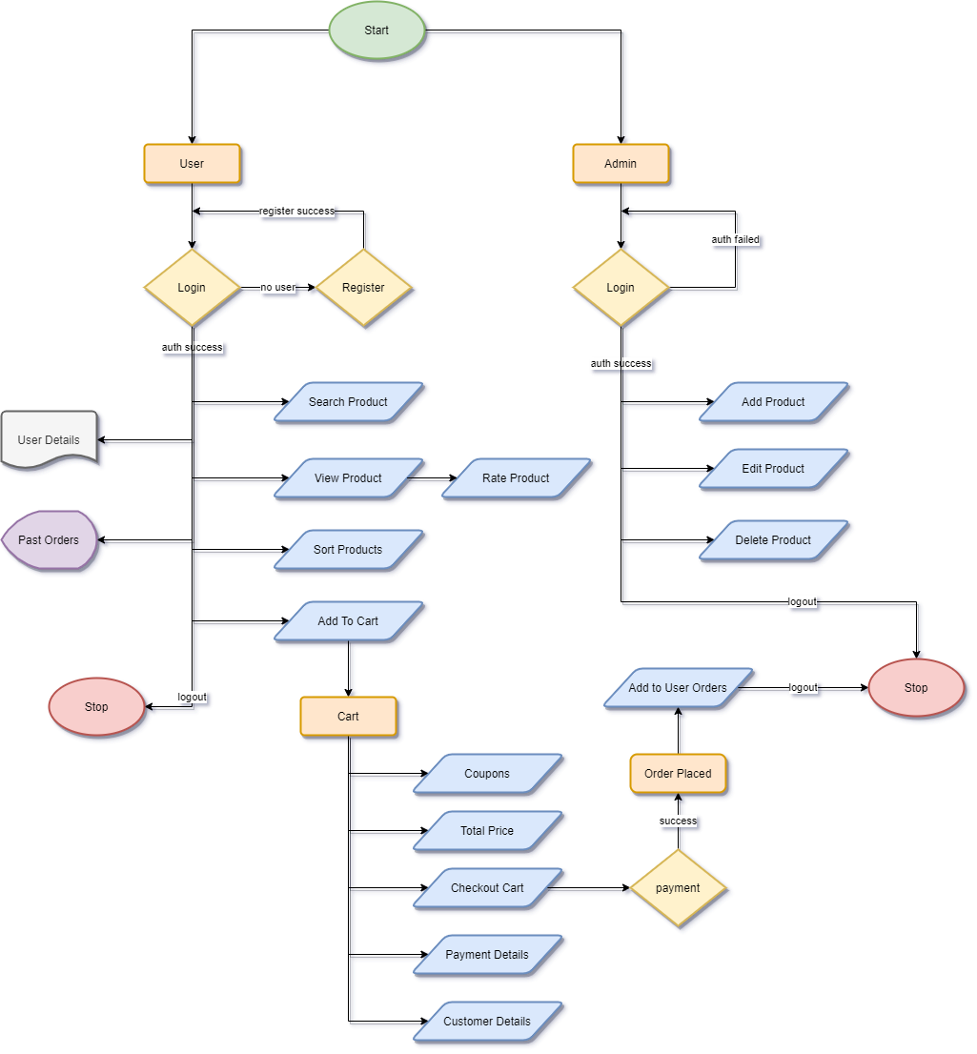

# Bibliography

1. RUAS SDF Lab Manuals, and Assignment of 4th semester, Satyajit Ghana, 17ETCS002159, 2018
2. ProjektPlutus – Satyajit Ghana – SDF Lab final implementation of Online Shopping Website using Angular 6, AngularFirebase and Bootstrap.